# | Diagram | Purpose
1 | System Architecture | Shows the complete technical stack
2 | Database / ER | Shows how the main data is connected
3 | Student Learning Flow | Shows how the actual product works
4 | Security + AI Architecture | Shows cybersecurity and AI/RAG flow

System Architecture

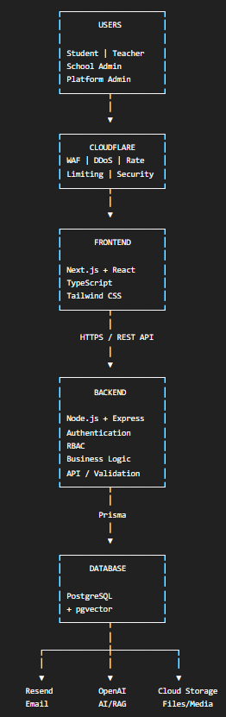
Database / ER

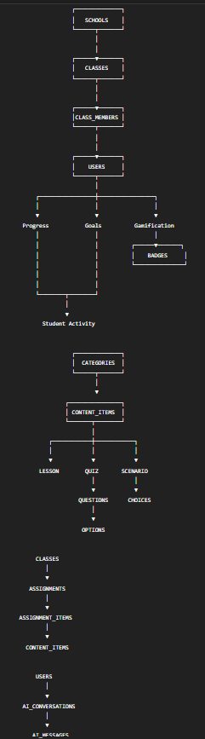

Student Learning Flow

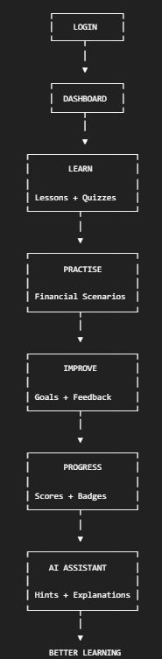
Security + AI Architecture

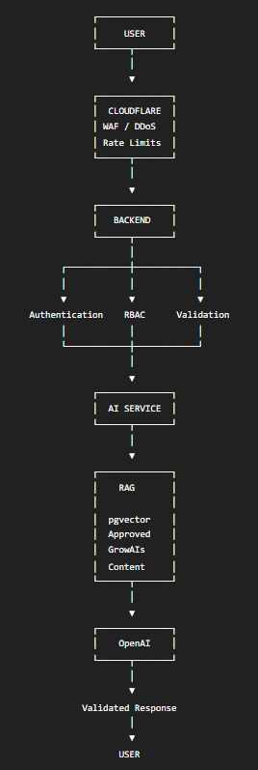

Tool/service | Initial choice | Starting cost
VS Code | Development | Free
Git | Version control | Free
GitHub | Repository | Free
Next.js | Frontend | Free
React | UI | Free
TypeScript | Language | Free
Tailwind | Styling | Free
Zustand | State | Free
Node.js | Backend runtime | Free
Express | API | Free
Prisma ORM | Database access | Free/open source
PostgreSQL | Database | Free/open source
pgvector | Vector search | Free/open source
Postman | API testing | Free plan
Playwright | E2E testing | Free/open source
Docker | Containers | Free options
Cloudflare | Initial security layer | Free plan
Resend | Email | Free up to 3,000 emails/month
GitHub Actions | CI/CD | Included usage
Sentry | Monitoring | Free tier available
OpenAI API | AI | Usage-based
Vercel | Frontend hosting | Free Hobby / $20 Pro
Render | Backend hosting | Free options / paid compute
Supabase | Managed PostgreSQL | Free / Pro from $25

